For First Terminal Examination -2083
Class-10
Subject: Optional Mathematics Course Contents:

Algebra | Functions, Matrix and Determinants
Trigonometry | Compound Angles, Multiple Angles and Sub-Multiple Angles
Coordinate Geometry | One Point Form and Two Point Form, Angle between two lines.
Statistics | Grouped Data, Quartiles and Mean Deviation
Continuity | All

For Second Terminal Examination -2083

Algebra | Functions, Matrix, Polynomial and Surds
Trigonometry | Compound Angles, Multiple Angles, Sub-Multiple Angles, Transformation of Trigonometric Ratios, Conditional Identities and Trigonometric Identities
Coordinate Geometry | Conic Section
Statistics | All
Continuity | All
Vector | All

For Third Terminal Examination-2083 Course Contents

- ALL courses according to CDC

EMBOCS NAWALPARASI
Specification Grid for First Terminal Examination-2083
S. N | Contents | Topic | K | U | A | H. A | Total number of Questions | Total mark
1 | Algebra | * Function | 2 | 2 | 2 | 1 | 7 | 16
2 | Matrix | all | 1 | 1 | 1 |  | 3 | 6
3. | *Coordinate Geometry | conditions for lines to be parallel and perpendicular | 1 |  |  |  |  | 1
4 | Trigonometry | - Multiple angle  - Sub – multiple angle | 2 | 2 | 3 | - | 7 | 15
5. | Statistics | All |  | 1 | 2 |  | 3 | 8
6. | Limit & continuity | All | 1 |  | 1 |  | 2 | 4
 |  | Total mark | 7 | 6 | 9 | 1 | 22 | 50

EMBOCS NAWALPARASI
Specification Grid for Second Terminal Examination-2083

S. N | Contents | Topic | K | U | A | H. A | Total number of Questions | Total mark
1 | Algebra | - Function  - Polynomials | 1 | 1 | 1 | 1 | 4 | 10
2 | Matrix | all | 1 | 1 | 1 |  | 3 | 6
3. | Coordinate Geometry | all | 1 | 1 | 1 | 1 | 4 | 10
4 | Trigonometry | - Multiple angle  - Sub – multiple angle  - Transformation of Trigonometric ratio  - Conditional trigonometric identities | 2 | 2 | 1 |  | 6 | 9
5. | Vectors | - Scalar product  - Vector Geometry | 1 | 1 |  |  | 2 | 3
6 | statistics | all |  | 1 | 2 |  | 3 | 8
7. | Limit & continuity | all | 1 |  | 1 |  | 2 | 4
Total |  |  | 7 | 7 | 7 | 2 | 24 | 50
Marks |  |  | 7 | 14 | 21 | 8 |  | 50

EMBOCS NAWALPARASI
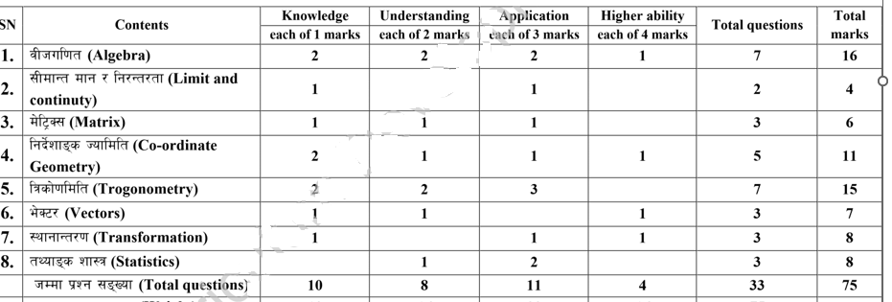
Specification Grid for Third Terminal Examination-2083

